Appraisal

Appraisal

**Objectives - These are the original user requirements from client.**

Note: The evidence for the objectives that have been met can be found in the testing table of my System Testing section. Go to the System testing section if you wish to view the evidence.

|  |  |  |
| --- | --- | --- |
| **Objective** | **Met? Yes/No** | **Comments** |
| A login system where each user can login | Yes | **Evidence**: Test 2, 24 and 49 |
| Three types of system users. Admin, teacher and student | Yes | Yes this has been implemented. |
| The admin should be able to create teacher, admin and student accounts | Yes | **Evidence**: Test 4, 13 and 21 |
| The system should be able to generate the username and email for each type of user automatically in the same way as the college. | Yes | **Evidence**: Test 4, 14 and 22 |
| The admin could create a class and assign teachers and students to a class. | Yes | **Evidence**: Test 9, 13 and 21 |
| The admin is able to edit and delete existing user accounts. | Yes | **Evidence**: Test 19 and 20 |
| System able to email teachers the login details of all the students in their class. | No | An alternative has been implemented where the teacher can export the login credentials of the students in their class to a .txt file. |
| A feature that allows teachers to export the MyGCSE maths account information of each student in their class. | Yes | **Evidence**: Test 31 |
| A teacher would be able to manually add questions into the system, including questions that have an image. | Yes | **Evidence**: Test 35 and 36 |
| A feature to generate questions of different topics types and difficulties levels. For example algebra, shapes, numbers and handling data questions. | Yes | **Evidence**: 32, 33 and 34 |
| The choice to generate multi choice questions and non multi choice questions. | Yes | **Evidence**: 32, 33 and 34 |
| Teacher should be able to add, edit and delete questions in the system. | Yes | **Evidence**: 42 and 43 |
| The teacher should be able to add quizzes/homework into the system for students to complete. | Yes | **Evidence**: Test 45 |
| Student will see all the outstanding quizzes/homework. | Yes | **Evidence**: Test 50 |
| The system should be able to mark student’s tests, and save their result so their teacher can see it. | Yes | **Evidence**: Test 57 |
| Teacher can search for students in their class by their name | Yes | **Evidence**: Test 26 and 28 |
| Teacher can view the progress for each test a student has completed over a period of time | Yes | **Evidence**: Test 65 |
| Teacher able to export a mark scheme for the questions and quizzes in the system. | Yes | **Evidence**: Test 47 |
| The teacher should be able to see what subjects each student and the whole class is doing well in. | No | I didn’t meet this objective. |
| Able to store lots of questions in the system for the student to practise. | Yes | The SQL database allows for large volumes of data to be stored. Also, using the question generator you could generate many questions instantly. |
| The system should be easy to use and not hard to understand | Yes | Yes, my user feedback supported. Both the users Sarah Okafor and Rachel Clark said that the user interface was easy to navigate and use. |

User feedback

From: Rachel Clark - Client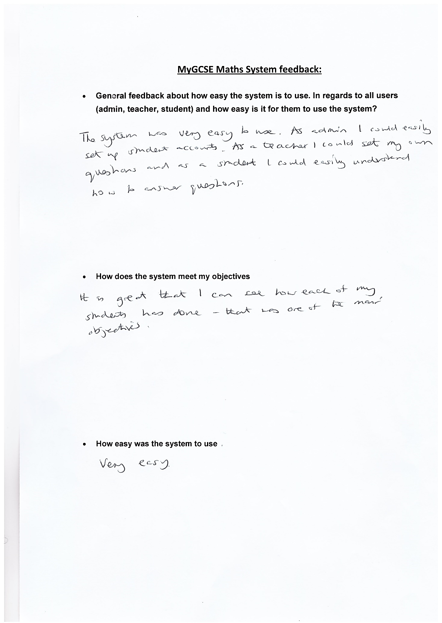

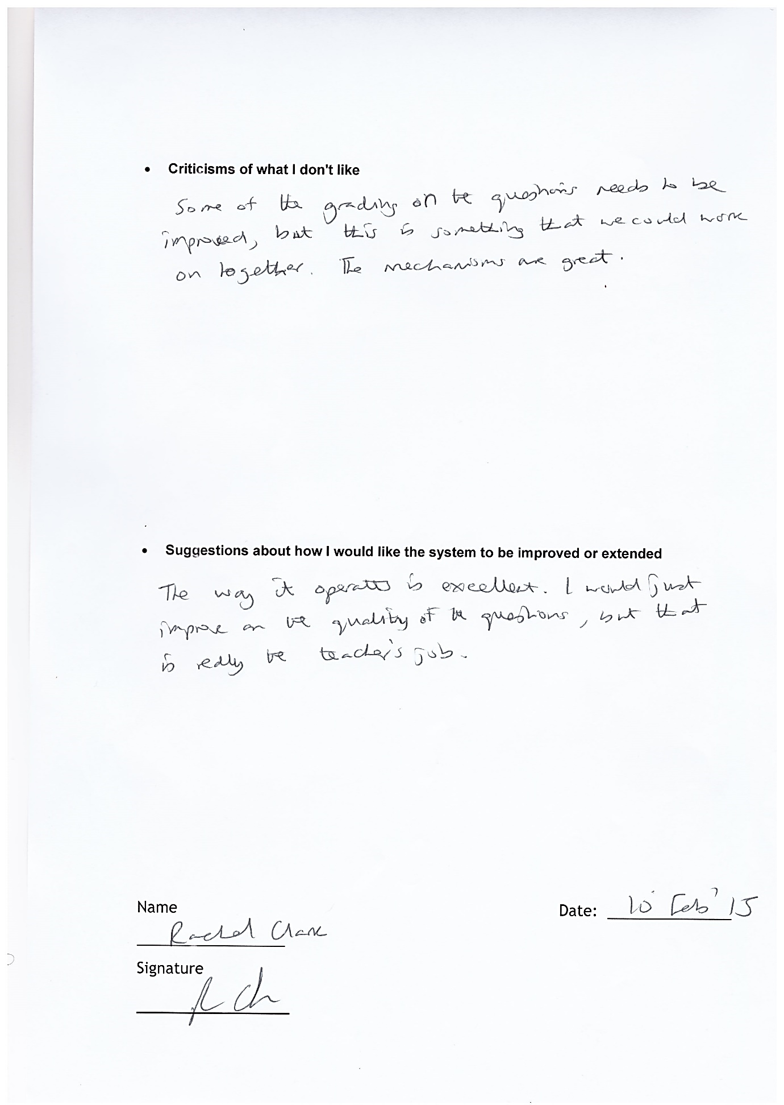

From: Sarah Okafor – GCSE Maths Student 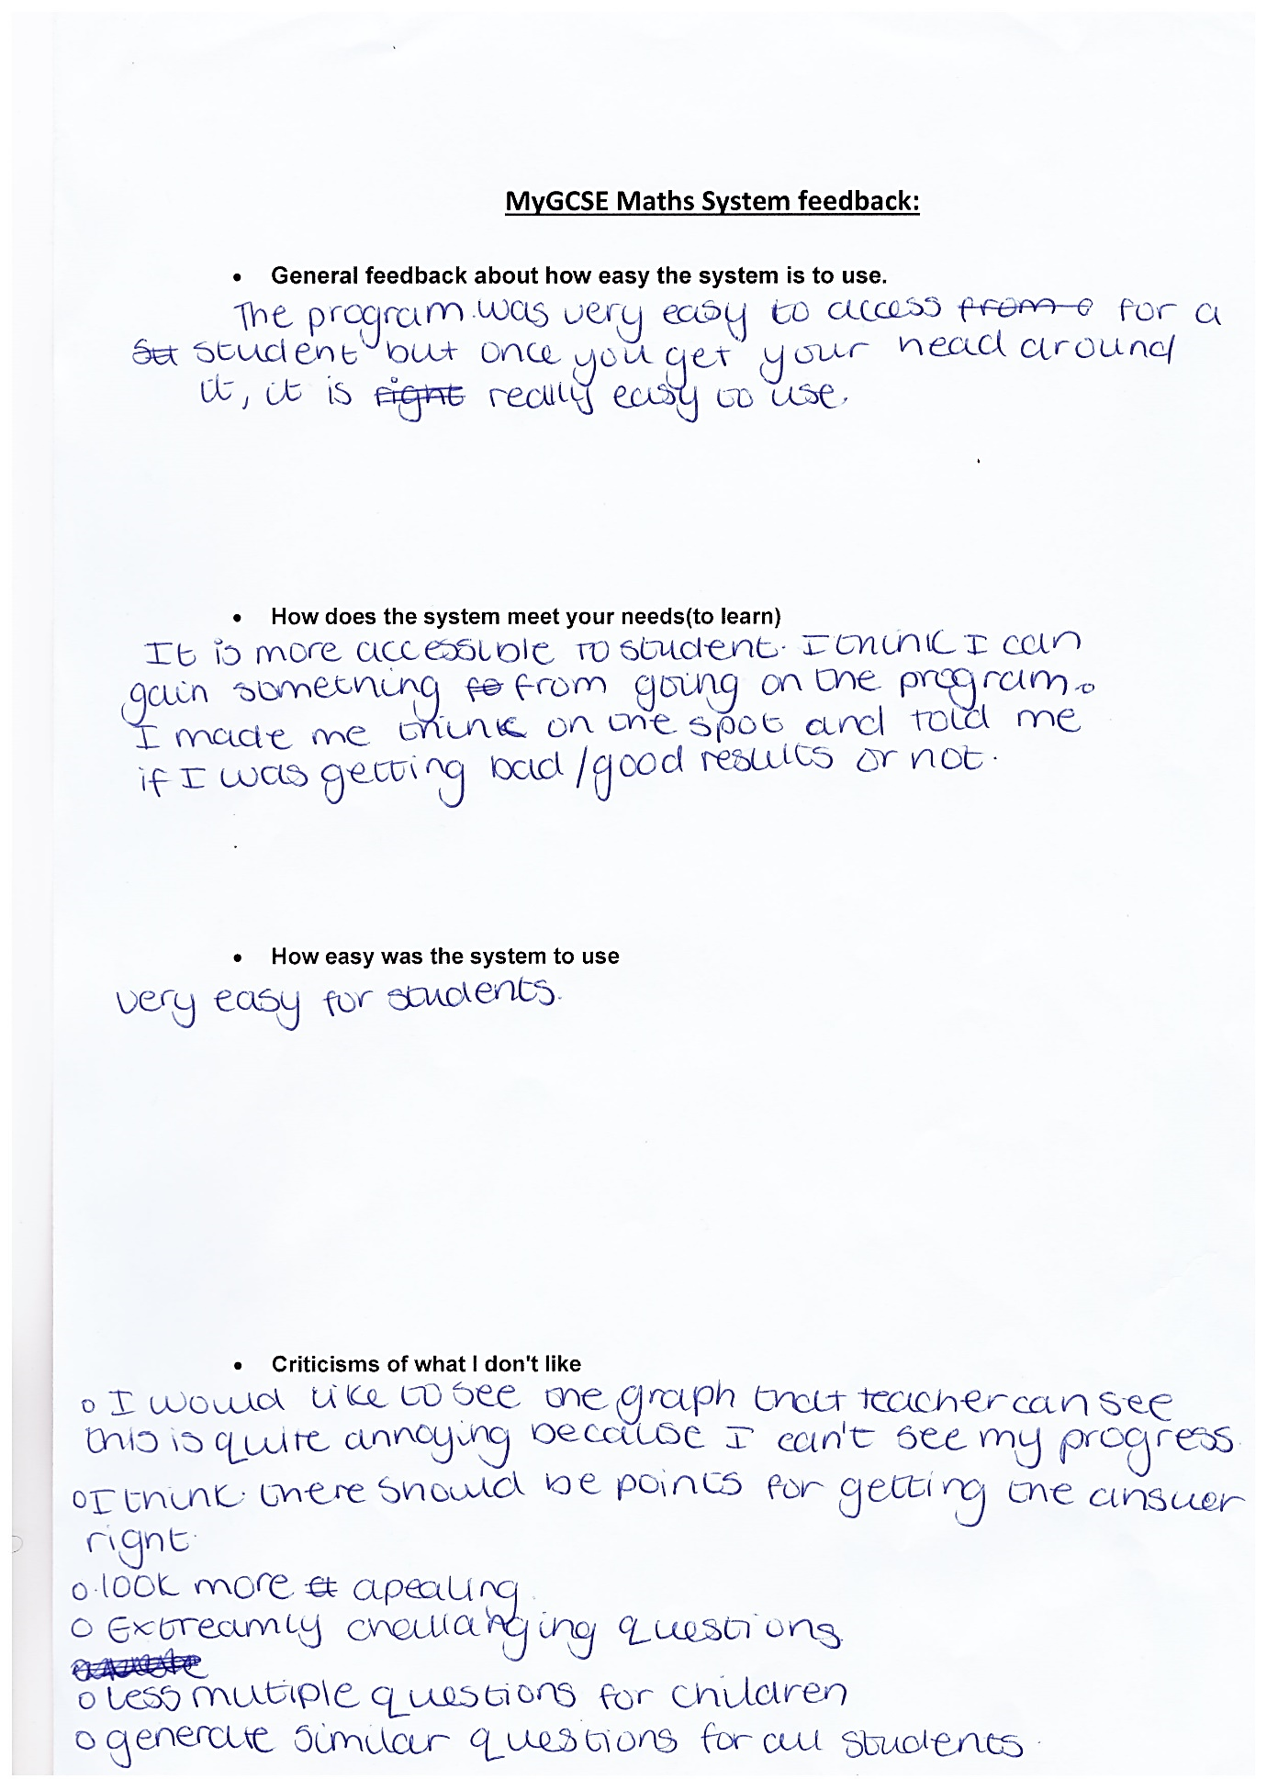

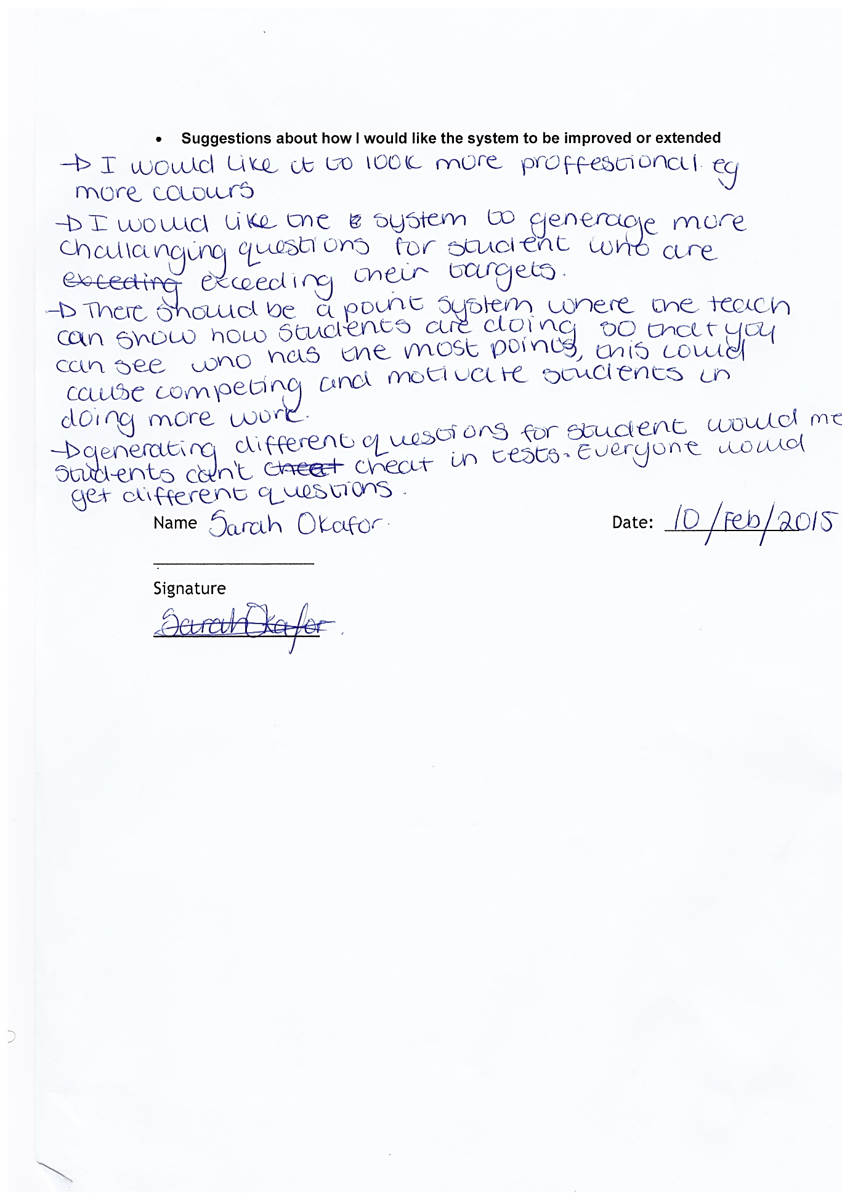

Feedback analysis

Analysis

After receiving the feedback from the different end users of my software, I would say the outcome is good in general. This means the program was well designed and robustly built in order to prevent errors, resulting in a better user experience.

I believe that I have developed the main concept for the program such that I could easily extend it to be more practical in real world environment. For example, I could adapt the system to work for users wherever they are in the world rather than a local network. Therefore teachers, students and admins could use the system anywhere, as long as they have internet connection. Also, since my code is easy to read and well organized, I could easily extend the functionality of the system. For example, I could implement a feature that allows for time based quizzes.

What would I do differently?

If I were to improve my system, I would ensure my question generating algorithms could generate more complex maths question that were challenging for capable students.

I would also extend the program to use an application program interface (API) to transfer data from a webserver to my vb.net application in order to remove the constraint of only being able to use my project on a local SQL database/server. If the program were to be hosted on a webserver, where all the data is stored server side, it could be accessed globally. This way students could complete work set by their teacher wherever they had an internet connection, meaning students could complete their work at home.

I would also make sure that the student could view their own progress in the same way teachers can view students’ progress. The user feedback suggested that adding this feature is important because students should be able to know how well they’re doing over a period of time so they can see if they’re progressing or not.

The user feedback from Sarah Okafor indicates the system should be able to generate challenging questions for high ability students. This is a good because higher ability students should be able to benefit from the system just as much as lower ability students.

Extension - Improvements

Improvement - 1

I could improve my system by removing the limitation of the system only working on a local SQL server. To accomplish this, I could develop a REST API using PHP as the scripting language and phpMyAdmin (MySQL) as the database backend. The remote SQL backend would replace the need for using a local MSSQL server database. This introduces the concept of server side and client side programming. To request data from the remote database, I would submit a GET request to the API to return the response object encoded in a JSON formatted string. For example, if I want to get information about a specific question for students to answer, I would perform a HTTP GET request using the WebClient or HttpWebRequest class in vb.net, read and parse the response in my program, then display it to the user.

*For example the request URL would look:*

<http://www.mywebsite.com/api/questions.php?action=getquestion&questionId> = 4521

*The response object would look like the image below.*

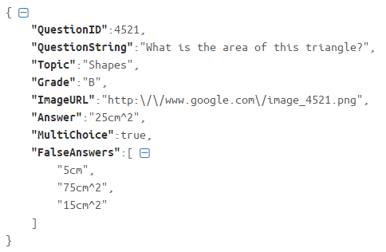

In my vb.net application, I could then de-serialize the JSON data returned, parse it and cast it to an object, then process it and display it to the user accordingly. Using this concept, I could rebuild every part of my system to work using an API. It would be easy to implement this system improvement as my system is fully coded and functional as all it involves is translating the vb.net code I’ve implemented to the PHP equivalent. In addition, the majority of the code in my business logic layer are functions that return an object, which already mimics the API concept where a data request performs tasks behind the scenes and returns a response object.

For example, in my QuestionHelper class I have a function called GetQuestion() which returns an object containing the data of the question requested. This concept is no different to using an API hosted on a webserver that returns data in a JSON formatted string.

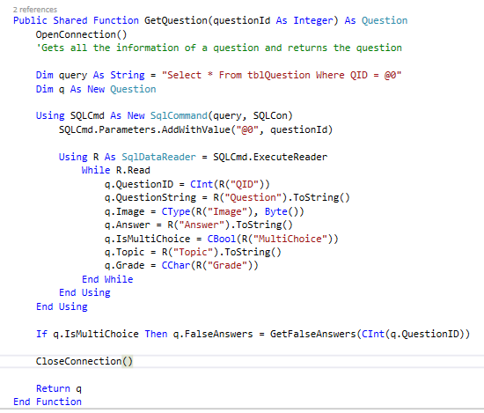

My VB.NET code for the GetQuestion() function.

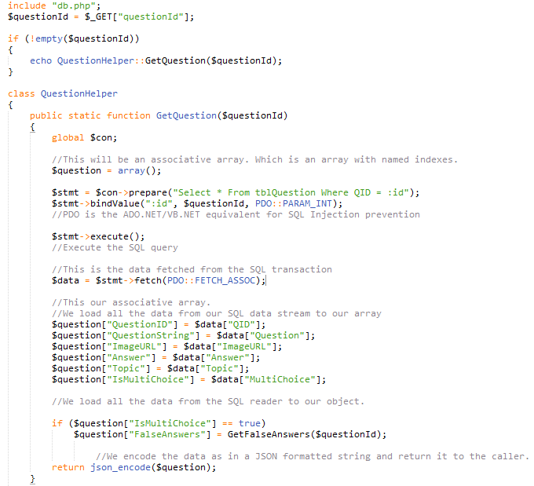

The PHP equivalent for my vb.net GetQuestion() function.

Implementing a system like this will reduce the security risk of a user decompiling the executable of my application in order to find out the SQL connection strings and possibly break into my database and tamper with the data. Now all the sensitive SQL data will be stored server side meaning data is safer than before.

Also, implementing this system means that my system could then be used without the restriction of having to be connected to a local MSSQL database. Therefore students could use the program at home as long as they have internet connection (which is more practical than only being able to access the system on a local network).

In addition, the use of the API means I could develop the “MyGCSE Maths” system for popular mobile platforms like android and iOS and use the same API to interact with the remote database. This means users can use the system as a downloadable app on their smartphones. Therefore changes made from the desktop version of the application would be visible on the mobile version and vice versa.

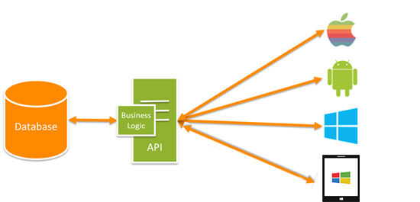The image below illustrates the described API system that I could potentially implement.

Each platform uses the same API to get, update and manipulate data. This is good because data is stored and is accessible from one central location.

Justification:

Although I could use ASP.NET to develop the API, I would have chosen to use PHP because I am more comfortable and familiar with creating web APIs using PHP in comparison to ASP.NET. Therefore, I would have chosen to implement the API using PHP because it would be easier and quicker for me.

Improvement - 2

I could add a feature to show the students the results of all the quizzes they had completed. This would be good for self-evaluation, so they know how well they’re doing and what to aim for. I could display this information graphically in the format of a trend graph or bar graph. Since I already have a progress viewer on the teacher form, I could easily implement this feature for a student with few coding modifications.

Improvement - 3

My system is currently restricted to generating square, rectangle and triangle questions, as it generates images using predefined sizes and location. One way I could improve this is by making it rotate the image, and being able to draw trivial shapes like trapeziums of different angles, sizes, and being able to label them correctly and work out the answer accurately (This then means my system won’t be restricted to being only able to generate square, rectangle or triangle questions).